46

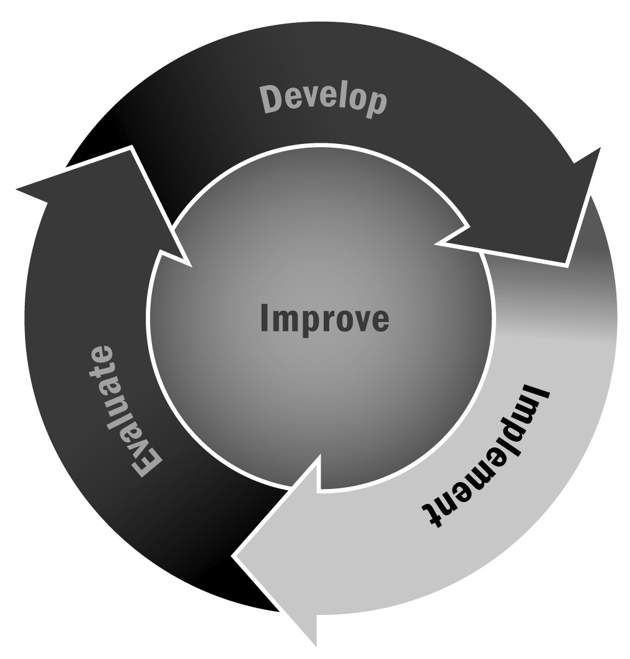
Draft Agenda for Meeting With the Principal
In Chapter 3, you learned that developing a positive relationship with the principal of the school or schools you work with is important. Setting up a meeting with the principal to discuss your partnership is an important first step in forming a successful relationship.
Directions: Use the form on the following page as a basic template for creating an agenda for your meetings with the school principal or head administrator, or for any other meetings you have. The agenda items will differ based on your needs for the specific meeting.

Tips for a Successful Meeting
- Start and end on time.
- Have a clear agenda and stick to it. Try not to get off on tangents or allow discussion to wander too far from the intended goals.
- Provide some kind of refreshments, even if they are just water or coffee. Food and beverages help people feel respected for their time commitment.
- Try to identify a nice meeting space. If your school or program has one, great. If not, see if a local business, a college or university, a partner nonprofit, or a local foundation has a nice room you can use.
- Mix up the format—have some presentations, some large group discussion, and some small group discussion.
- Pick meeting times that are agreeable to everyone. If you have families and youth on your board, be sure your meetings are after school, in the evening, or on weekends.
- If you have guests from a variety of local organizations, they may want time to network at the beginning or end of the meeting. Consider offering food or coffee for 20–30 minutes at the beginning or end of the meeting.

[Program Name] Principal Meeting
Agenda
[Date] – [Time]
Meeting Goals
- Include three or four goals for the meeting. Any more will feel overwhelming, and fewer may make the meeting feel unnecessary.
- Goals should be broad things you want to cover in the meeting. They might include things you want to inform your board about or key decisions that need to be made.
- Sample goals:
- Share new discipline policy and get reactions/edits before disseminating to families
- Determine date for spring gala fundraising event
- Come to agreement on decision to expand program by an hour next school year
[Start time] | Introductions and Agenda Description  Everyone should introduce themselves, their role, and their organization for the first meeting. If you have guests who attend, it may be a good idea to do this every time. Consider some kind of icebreaker or opening activity when appropriate. When you review the agenda, invite others to suggest additional topics that they would like to discuss.
[Start time + 10 minutes] | Meeting Norms  Establish or reiterate the rules for the meeting and group discussion. Determine and/or confirm the principal’s preferred methods of communication.
[Time] | Agenda Item 1  Suggested topics may include shared responsibilities (using Tool 45), space and resource allocation, updates on youth who attend the program, academic alignment, or communication with teachers and other staff.
[Time] | Agenda Item 2  Try to vary the format. Don’t simply have three large group discussions. You might have attendees break into pairs to review the discipline policy and then come back together to discuss. Or you might have a short presentation on why you want to expand the program and then break into small group table discussions before coming together again to make a decision.
[Time] | Additional Agenda Items
[Time] | Closing and Next Steps  Be sure to end the meeting on time and have some kind of closing activity—whether it is reviewing the final decisions that were made, talking about next steps, or simply asking everyone to reflect on the group process. Closure and reflection are important to any successful meeting.  Be sure to use this time to confirm the time and location of the next meeting.
[End time] | Adjourn

